**Prevalence of Autoimmune Diseases in Bangladesh & implementation of Immunopharmacology**

**Abstract:** The summary of the whole project

**Introduction:**

* What is immune system
* What are immune disorders

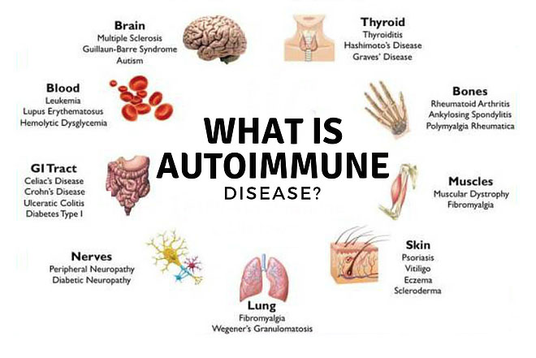

* The most dominating autoimmune disorders in Bangladesh **(pie chart)**

**Causes of Autoimmune Diseases:**

**Classifications:**

**Management:**

**Correlation between Immunopharmacology & Autoimmune disorders:**

**The Expanding Role of Immunopharmacology:**

An external file that holds a picture, illustration, etc.
Object name is bph0172-4217-f2.jpg

**Conclusion:**

**References:**